

# Hillcrest Summer Newsletter 2014

Over the last term we have developed our new mission statement that will be at the heart and soul of everything that we do. Please feel free to get in touch if you have any comments about it.

**Mission Statement**

**“Aiming High: dream, believe, achieve”**

We believe in, and strive to create, a community of learners where everyone feels valued in a welcoming, supportive and safe environment, based on unconditional positive regard.

When students leave Hillcrest School, they should be more resilient, confident, responsible, independent, respectful and life-long learners.

**Our Aims**

* To provide the highest standards of teaching and learning through setting challenging educational experiences that recognise everyone’s potential from their own starting point and building on their success.
* To encourage a community of learners with positive attitudes to learning.
* To promote an atmosphere of mutual respect, where students have a voice in the school and their views are sought and listened to.
* To encourage high standards of behaviour where students are encouraged to manage their own behaviour, take responsibility for it and recognise that actions have consequences.
* To build strong partnerships with parents and carers.
* To maximise all possible opportunities to forge strong links within our local community to enhance and exploit all learning experiences.

**Alternative Lightwater Valley Trip**

Every year the Friends of Hillcrest fund a school trip to Lightwater Valley. This summer, however each year group decided to do their own trips. Instead they were given the equivalent budget and they researched and planned their own trip. Most year groups opted for a trip to the Cinema and a meal.

Each year group enjoyed planning their trip and would like to thank the Friends of Hillcrest for their generosity and allowing this to happen.

**Year 7**

Year 7 had a trip to Beamish Museum in County Durham. We had a lovely sunny day to explore the museum. We donned hard hats and descended down the mine to discover the very difficult conditions that miners work in. We rode on the open top tram and of course we had to go on the top deck. We had a lovely picnic lunch and then a delicious ice-cream. The best part of the trip was the old fashioned sweet shop.

A good day was had by all.

**Project Based Learning – Year 8**

Year 8 enjoyed their week of Project Based Learning about Spain.

The pupils communicated in Spanish learning greetings, colours, numbers and days of the week. They also examined the work of several Spanish artists, including Picasso and Salvador Dali; using these artists as a stimulus for creating their own art work on canvas with oils.

The pupils particularly enjoyed going on a picnic to sample some typical ‘tapas’ foods and having a siesta under the trees!

Above all, Year 8 were engaged and extremely motivated to learn throughout the project. To conclude, Project Based Learning encouraged a deeper level of thinking by involving the pupils in answering questions for themselves and making connections using analytical skills.

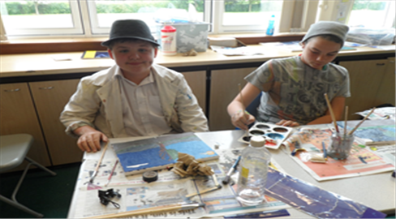

**Year 9 –Project Based Learning Week**

Students in Year 9 worked as a team setting up a new fish tank with live plants. They chose creative names for the new fish.

They worked really hard producing an easy to use guide with pictures to help our new students look after the fish. Several versions were made and students critiqued their work and decided on the final version.

The fish are now settled in their new home and like their new environment!





**My Bike Ride**

Hi my name is Luke Morrison and I’m going to tell you about my charity bike ride.

I decided to do a sponsored bike ride through my educational journey for Cancer Research U.K.

So I started at Hillcrest then I went to East Hartford then to The Dales then to Wansbeck First School then I finished at Red Row First School a total distance of 30.2 miles.

It took me 2 hours so I had an average speed of 15.1 mph and I raised £254

C:\Users\cmcveigh\AppData\Local\Microsoft\Windows\Temporary Internet Files\Content.IE5\MQYQ70Y7\MC900197730[1].wmf

**Project Based Learning Year 10’s**



Year 10’s visited Ulgham Wildlife Sanctuary as part of their PBL ‘I Dig This!’ where they learned about the animals and what they could do to help attract, protect and preserve wildlife in our Local Community. Staff made links with local businesses including Asda and received donations. Dorothy Laing, Asda’s Community Liaison Worker joined us on our trip. Kim who owns the Sanctuary said it would be a pleasure to offer work experience placements in the future to students at Hillcrest as a result of our visit.

Lisa Grear & Emma Williams

**Getting In Touch**

Following their last very successful project (Arriva Buses have taken the leaflet produced by Year 11 and had in printed professionally and put it onto their buses) the class was really buzzing with excitement. Darren had previously wanted to do something for charity so with this in mind, ideas were discussed. Eventually pupils decided that they would like to raise money to sponsor a guide dog puppy. They wanted approval from our Head but said it was not always easy to get to speak to her. This dilemma led to the next part of our project which was to design a system of communicating with Mrs Mead. The rest, as they say, is history. There is now a hopefully efficient system (it will be reviewed next term) of getting in touch with the Head and Year 11 have successfully began their fund raising. There will be a ‘Wear neon to school’ day next term – details will be on our school website.

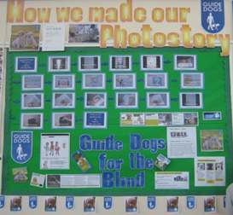

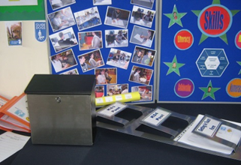

**Amy Kennedy**

We are all so proud of Amy, one of our sixth formers who will be leaving us to start an Apprenticeship at a local school. This is an excellent opportunity for Amy. Although we will miss her enormously, we wish her well in her new venture.

**Staffing**

The start of the academic year brings new staff. Mrs Ross Ballard will no longer be an HLTA in school, but will be the new class teacher for The Base. She will be replaced by Mrs Hawkins and we also have Mr Williamson joining the team as a Cover Supervisor. Mrs Goodrich will be back doing one day a week regular supply in school.

**Groupings**

As of September classes will not be called by year group. This is because the classes are made up of pupils from different year groups. KS3 now has 4 classes instead of the usual 3. This is so that we can better meet the needs of all of our students. Classes KB and EW will be taught Literacy and Numeracy in groups of 6, to try and accelerate the progress pupils make in these subjects.

|  |  |
| --- | --- |
| Class Mix | Known as |
| 7/8 Mix | EW |
| 7/8 Mix | KB |
| 7/8/9 Mix | ERB/The Base |
| 9 | AB |
| 9/10 | SD |
| 10/11/12 | CL |
| 6th form | 6th form |

I would like to thank all of the parents and carers who have supported Hillcrest over the last year to make my first year as Head Teacher enjoyable and productive.

The highlight for me was our Exhibition and Family Picnic Day on Thursday 17 July. We had a huge turnout for this event with 18 families attending. It was a joy to see proud parents, and other family members in school to view the projects. The pupils and staff worked hard to produce amazing results.

Have a great summer. I look forward to the new academic year to continue moving the school forward. School re-opens on Tuesday 2 September.

Mrs A Mead

Head Teacher