

Cramlington Hillcrest School

SEN Information Report- April 2021

Hillcrest School is an OFSTED rated ‘good’ specialist provision for students aged 11-18 years old based in the centre of Cramlington. Although a relatively small school of 101 pupils we pride ourselves on being an integral part of the local community and extend our offer to all of Northumberland, including some pupils from North Tyneside..

**What does a child need to attend Hillcrest School?**

All learners wanting to attend Hillcrest will have an EHCP or be going through the process of finalising an EHCP. Although Northumberland County Council are the Admissions Authority places will be requested via the SEN team for the attention of the school Leadership Team. This is to ensure that pupils needs can be sufficiently met with the resources, curriculum and that the pupil would have a peer group in which they could be accommodated.

Parents/carers/pupils are welcome to contact the school for further information. Whereby a place is requested then visits can be arranged.

**What kinds of special educational needs does Hillcrest cater for?**

Our staff expertise and resources are ideally suited to meet the needs of students whose EHCP states:

* Autistic Spectrum Conditions
* Speech, Language and Communication Needs
* Social, Emotional and Mental Health Needs
* Sensory Needs
* Cognition and learning Needs

**Why are our pupils successful?**

One of the most crucial elements of our school are the extensive staff team. Currently the school has almost 50 staff who pride themselves on being pupil centred, solution focussed and want to ensure every child is ready to learn- removing barriers and building on successes.

We all share and promote the school ethos and key drivers, which are;

‘Dream, Believe, Achieve’

* Social development and communication
* Emotional health and wellbeing
* Academic achievement
* Functionality (the ability to apply knowledge, skills and understanding)
* Aspirational Futures (careers and further learning)
* Resilience

**CYPS (Children’s and Young Peoples Service) NHS School Nursing/Health Team Children’s Services**

**Barnardos (EHA) Action for Children (EHA) ESLAC (Education Support for Looked After Children) Educational Psychologists Occupational Therapists Northumbria Police Education Welfare Officers**

**How does Hillcrest School involve other bodies in meeting the needs of pupil and their families?**

We understand the importance of multi-disciplinary working and as such work closely with professionals from all field and including the voluntary sector. Some of the key professional agencies we regularly work with are listed below.

**What resources do we use to support the curriculum and how do we adapt the environment for our pupils?**

The school premises is constantly under review to ensure we maximise the offer for the young people here at Hillcrest. Over the last few years we have invested significantly in the site to support teaching and learning. Specifically;

* refurbished the school sports/dining hall
* developed a school allotment and garden
* created a 6th form specific provision
* changed an onsite bungalow into small group teaching areas, meeting rooms, library and independent living teaching area
* had a MUGA installed to enhance play and sporting activities
* installed a Yurt for Thrive and Forest School sessions
* divided up the school playing fields to create a forest school/nature area
* created purpose intervention spaces within the main school, including sensory areas
* overhauled our school cookery/craft room
* created small group and private work areas around the school
* class rooms have developed their own safe spaces
* a chill zone where students can regulate
* an age appropriate OT studio
* Rebound therapy – 2 staff to be training summer term to deliver sessions

Further to this we have;

* A school minibus so students can access learning in the community
* A school car so that small groups can go out for interventions or that staff can visit parents/carers or professional meetings

We have bespoke approaches to how we work. All classrooms are different in the way they look and how they are resourced. Staff teams work hard to ensure there are sufficient resources in place to support access to the curriculum.

**How are pupils involved in their education?**

We feel that pupil voice is an incredibly important part of pupils valuing their education offer. Within the staff teams pupils are actively encouraged to talk about learning, school life and the challenges they have. We also take the opportunity to celebrate progress and achievements in groups and as a whole school.

The school leadership team have an active role around school and as such develop equally positive relationships with all students. This ensures they feel confident to approach any school leader to discuss worries, challenges or share ideas they have about their education.

As part of the EHCP process students are invited to be actively involved about giving their views, contribute to the targets and discuss progress towards these. This also helps to shape their curriculum offer.

As part of a collective voice, Hillcrest has a school council who have specific and evolving roles throughout the school year to influence change within the school. We have elections every year and students are represented in each key stage.

The school leadership team also seeks views from pupils and conducts annual questionnaires to capture their open and honest views about the school.

**How do we review the EHCP outcomes and use these to prepare for adulthood?**

As part of the annual EHCP process outcomes are agreed, reviewed and new challenges set. The evidence to show how these are met can come from the curriculum assessment, home/school observations, parent/pupil feedback or professional reports.

At Hillcrest we use provision mapping to ensure that all outcomes for every child are mapped and tracked during their Hillcrest attendance. As part of the process outcomes are also considered in preparation for adulthood.

As part of the Yr9 + EHCP meetings transition is a key focus to ensure provision and accreditation become part of the review so learners can plan for their future.

**What does learning look like? How do we know if our students are making progress?**

Staff teams creatively plan each pupils learning journey and where required will make this bespoke to support the needs of the individual learners. We believe that for all of our learners to have success and independence into adulthood we need to deliver much more than the National Curriculum. We strongly believe that the holistic curriculum is essential for our students to be able to access the academic curriculum.

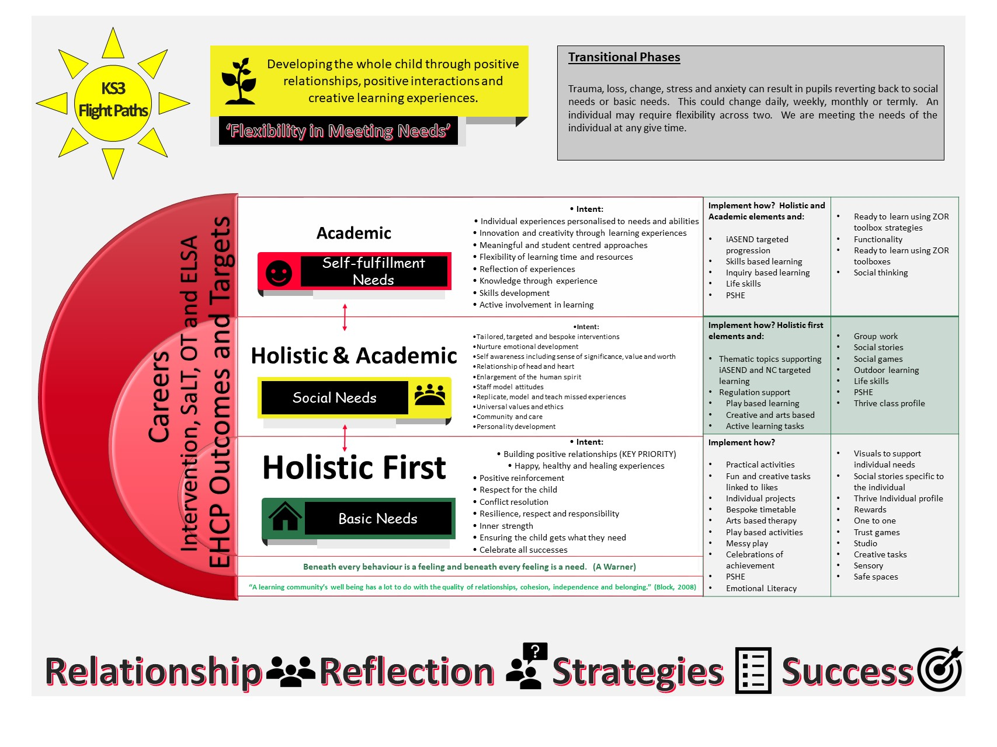

Staff at Hillcrest carefully match the national curriculum to the needs, interests and abilities of the students. Staff map learning through topic or thematic sessions so that the students can make connections with knowledge, skills and understanding from across different areas of the National Curriculum.

To measure progress we use a specialist SEND tracking system called iASEND. This recognises that students do not make progress as a constant trajectory but that learning needs time to embed, connect with previous learning and experiences. For each national curriculum area the curriculums are broken into ‘I can…’ statements where the depth of progress is measured across a 5 point scale, from emerging to embedded.

KS 4/5 progress is assessed using an in house assessment tool linked to accreditation.

Holistic progress is measured using individual and class THRIVE profiles with case studies to support as evidence.

**How does the school keep you up to date about any progress (or worries)?**

We feel that the home-school relationship is incredibly important to support any young person. We have an open door policy so that any parent/carer is welcome into school to discuss any matters. As we know, for some, visiting the school is difficult so we keep in touch through phone calls, text or e-mail.

At the start of each half term parents/carers will get a topic overview which will visually show what the key focus for learning will be. At the end of each term we then send a Termly highlights flyer which will share what your young person has been up to. This is also supported by an EHCP annual review and parents’ evenings.

The academic report will detail progress across all areas of the curriculum, % of progress made on iASEND (our assessment system) and comments from the class team.

ELSA Training for all support staff 2019-2020

Makaton Training

Speech, language and communication bespoke CPD - teachers

THRIVE Training

E Safety

Annual Face to Face Safeguarding Training Update

Occupational Therapy Training including Studio plans

Trauma & Attachment Training

ACES Training

ASC specific training/support

Pathways and Curriculum Training Day (Teachers only)

Zones of Regulation

Blank Level Questioning

Action Learning Sets

Growth Mindset

Resilience and Wellbeing

**How do we ensure students have positive mental wellbeing?**

As mental health is now a key priority within society we have continued to extend our provision and resources to support the young people here at Hillcrest, including their families and carers. We have gained the Carnegie School Mental Health Silver Award. One of the main tools we use in school is ‘Zones of Regulation’. This is a tool used throughout the school to support students in identifying how they are feeling, communicate this and a list of bespoke strategies they can use to support them in getting back to the ‘green zone’. Furthermore, the tool allows adults to develop reflective and coaching conversations.

We also develop positive mental health through;

* LCT- Learner centred time is reflective time to support regulation after each transition within school
* the use of the Thrive approach and bespoke curriculums
* developing friendships/positive relationships
* nurture group at unstructured times
* supporting families – staff teams, SLT and Intervention Team
* a positive attitude towards play and physical activity
* support around e-safety
* support our students in making healthy/positive choices
* Morag- our therapy dog
* developing our outside wellbeing area including a wellbeing hut and outdoor gym

One of the key resources we have in Hillcrest are the support staff who have all been trained as ELSAs (Emotional Literacy Support Assistants). This ensures that within each classroom we have the highest skilled practitioners on tap to support the pupils.

**What expertise and training do staff at Hillcrest have?**

To be able to support the young people here in Hillcrest it is really important that staff have the right tools, skills and resources to allow them to be successful in helping the students. We ensure we invest in quality CPD and below is a list of the most recent training (not exhaustive):

**What specialist services and support are available at the school to support students?**

We are really fortunate to have a skilled staff base within our teaching team and further more we have invested in our own intervention team which consists of;

* Senior Occupational Therapist – Oversees the OT work within school, allocates provision and works with most complex cases. Would also provide training and CPD school wide
* Occupational Therapist – Delivers the core of therapy and interventions within school, support delivery of curriculum and resource allocation
* NHS Speech and Language Therapist- Oversees the core NHS caseload within school but works alongside employed therapists
* Speech and Language Therapist - Provides the enhanced offer to specifically support pupils, staff and ensure planned interventions are implements and delivered. They would also provide school wide CPD.
* Senior ELSA (Emotional Literacy Support Assistant)- Delivers targeted interventions and supports students in crisis, leads on support for families and carers, key driver for wellbeing across the school for students & staff and supports pupil voice
* HLTA delivering Zones of Regulation and Social Thinking curriculum working alongside SaLT.
* ELSA trained TA’s running interventions in classes

The support and intervention offered can be one-to-one, small groups, whole class or across the school.

**How do we support transition?**

For any young person attending Hillcrest it can be daunting and we need to ensure, from the onset, we can relieve any anxiety for students as well as parents/carers. We have two types of transition: September cohort and in-year admissions. With both;

* we try to ensure that we collect as much relevant and up-to-date information about their needs so we know which resources and how best to share these with them
* we strongly encourage parents/carers to visit school to meet the staff team
* we allow the young person to see the classroom and meet the class team
* we plan gradual transitions where necessary
* we remain in regular contact with parents/carers so they are kept up to date
* home visits by staff teams
* visiting pupil in current school if applicable

We also work closely with Post 16 providers to support transition for students who are moving to new provision.

**How do we support parents/carers and families?**

We have an open door policy at Hillcrest. We have regular contact with parents/carers including phone calls. Our Intervention Team works closely with a number of parents/carers supporting with advice, guidance and resources, bridging the gap between school and home.

Further to this we actively advocate for those parents/carers requiring support from other professional services as well as putting our own referrals in for those families that want additional support.

As we aim to have a consistent class team working with the young people, parents/carers can build strong working relationships with trusted adults to support and ensure needs are being met.

**What links does the school have with the community?**

Although our school is in the South of Northumberland our catchment area is much larger. Our main community links are within Cramlington itself. We have had significant support from Cramlington Town Council, St. Nicholas Church, Asda, Manor Walks shopping Centre, Concordia Leisure Centre, Azure Garden Centre, Cramlington Foodbank and Aldi. Because of links that staff and pupils have our support network has extended much further and have included local businesses, trades, emergency services, colleges and sports clubs.

**How do our students travel to school?**

Hillcrest in an inclusive school and we have students attending from all over Northumberland, including some from North Tyneside and Newcastle. Transport is arranged through the local authority to ensure they maximise the routes and journeys into school. Hillcrest has little involvement with the selection of transport but are consulted regularly to ensure the journey into school and home is as enjoyable as possible.

We do have some students that walk into school and cycle. We would only recommend this if the student was living within close proximity to the school, at least Cramlington. Some of our students are dropped off by parents/carers if that is more convenient for them.

Website: <http://www.hillcrest.northumberland.sch.uk/>

School Office: (01670) 713632

E-mail: admin@hillcrest.northumberland.sch.uk

**Postal Address**

*Hillcrest School*

*East View Avenue*

*Cramlington*

*NE23 1DY*

000

**Who can I contact for further information about the school?**

**Where can I find the local SEND offer for Northumberland?**

<https://www.northumberland.gov.uk/Children/Northumberland-Local-Offer-SEND-0-to-25-years.aspx>

The following guide is available to download or read online.

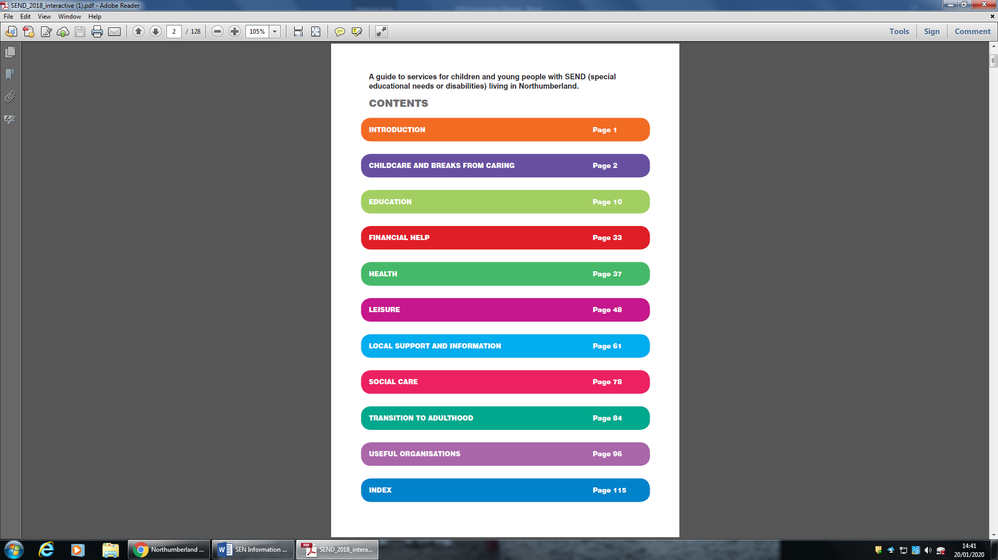

**What can you do if you feel the Local Offer is not being met?**

If a parent/carer has concerns about the provision available to their child at Hillcrest they are invited to discuss these promptly with their child’s class teacher, school leaders or with the chair of governors.

EHCP officers and the Local Authority SEND team can support parents/carers once other routes have been appropriately followed.

**How is the effectiveness of the school’s provision evaluated?**

The effectiveness of the school is evaluated in 3 ways: by the school leadership team (validated by the governing body), by the school improvement partner (Local Authority) and OFSTED (Her Majesty’s Inspectorate). The approach by each will be briefly described below.

School Leadership Team (inc. Governors)

School leaders drive to keep school improvement as a continuous cycle. Each year the School Development Plan is published, sharing foci across the school, responsible staff and steps for when/how these will be achieved. These are validated and closely scrutinised by governors. Termly headteacher reports share progress and this is gathered together in the school SEF (self evaluation form) at the end of each year which details the progress made and steps for further improvements.

School Improvement Partner (Local Authority)

The school improvement partner is a respected and credible school leader who works in partnership with the school and local authority to monitor, challenge and validate a schools performance. Our SIP visits at least termly and on each visit will validate evidence provided by the school and observe practice within classrooms. This report is then shared with school leaders, governors and the local authority.

OFSTED (National Inspections)

These are held, without notice, over approximately a 4 year window. These can be either a section 5 or section 8 inspection. The value of these inspections is to review the schools performance against national criteria and graded accordingly. A section 5 is a full inspection where each aspect of the school’s performance will be graded. A section 8 is an interim inspection that validates the schools progress and ability to maintain its current grading.

We see each aspect of school evaluations as a positive approach to ensure we are offering our students the very best offer.

**SENCo – Alison Miller**

Tel: 01670 713632  
Email: admin@hillcrest.northumberland.sch.uk

**School EHCP Officer: Sharon Pearson**

Tel: 01670 620177  
Email: [sharon.pearson@northumberland.gov.uk](mailto:sharon.pearson@northumberland.gov.uk)

**Who can I contact for direct support about SEND or EHCPs for my child?** 

Northumberland Information, Advice and Support Serviceis a free, confidential and impartial service for children and young people (up to 25 years) with special educational needs or disabilities (SEND), and their parents and carers.

The information, advice and support provided by the service covers the full range of education, health and social care as defined in the SEND Code of Practice 2015. The service is run at ‘arm’s length’ from the Local Authority.

The support the service can offer includes:

* Providing a listening ear and practical advice and support with understanding the SEND ‘system’
* Information on a range of SEND topics.
* Support with preparing for meetings.
* Help with exploring the options for a child/young person’s SEND provision.
* Signposting to other services and groups, including parent groups, youth forums and national helplines.
* Support for individual children, young people and their parents that empowers them to express their views and wishes and helps them to understand and exercise their rights in matters including SEN processes, exclusion, complaints and SEND appeals.
* Training for parents, children and young people, and professionals to increase their knowledge of SEND law, guidance, local policy, issues and participation.

The website for the service provides further details and can be accessed at [northumberlandiass.org.uk](https://northumberlandiass.org.uk).

The service operates on a self-referral service basis and can be contacted by phone on **01670 623555** or by email at[**iass@northumberland.gov.uk**](mailto:iass@northumberland.gov.uk).

**Sarah Jordan**SEND Team Manager

SEND Assessment and Monitoring Team

Wellbeing and Community Health Services Group

Northumberland County Council

County Hall  
Morpeth

Northumberland

NE61 2EF

Tel: 01670 622758  
Email:

[Sarah.Jordan@northumberland.gov.uk](mailto:Sarah.Jordan@northumberland.gov.uk)

**What support services are available to me and my child?**

*Please see the Northumberland Guide to Services for detailed contact information for services relating to Childcare, Education, Financial help, Health, Leisure, Local Support, Social Care, Transition to Adulthood and Useful Organisations.*

**Aspire Children’s Services**

Commissioned by Northumberland County Council to give Independent Support and Advice around Education and Healthcare Plans.

[jane.harrison@aspire-cs.co.uk](mailto:jane.harrison@aspire-cs.co.uk)

**North East Special Needs Network (NSNN)**

A parent led charity for parents/carers of children with disabilities.

www.nsnn.org.uk

0191 281 2485 (Main Office)

0191 281 2255 (Advice Line)

**Parent/Carer Forum**

A group of parents/carers who work closely with service providers to improve services for our children.

www.in-it-together.org.uk

07729 192 909

**Contact a Family**

A charity to support families of children with disabilities.

[www.cafamily.org.uk](http://www.cafamily.org.uk)

**Autism Northumberland**

A Family run Charity based in Northumberland, who support Families of children living with Autism

[www.autismnorthumberland.co.uk](http://www.autismnorthumberland.co.uk)

**Ability 2 Play (Active Northumberland)**

Offering Inclusive Leisure Facilities aimed at Young People with Disabilities

01670 622181

www.activenorthumberland.org.uk