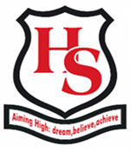
Hillcrest School
School Uniform Order 2018

Item | Size | Price | Quantity Required | Total Price
Turquoise Polo Shirt (Years 7-11) |  | £10.00
Turquoise Hoodie(Years 7-11) |  | £13.50
Green Polo Shirt (Sixth Form) |  | £10.00
Green Hoodie (Sixth Form) |  | £13.50

Total to pay £………………

Pupil name ……………………………..…………………………………….

- I enclose a payment of £……………..
- I will pay when I collect uniform

(Uniform must be paid for before it is given out)

Signed …………………………..…………….…. Parent/Guardian

