Beware of Free School Meals Email Scam
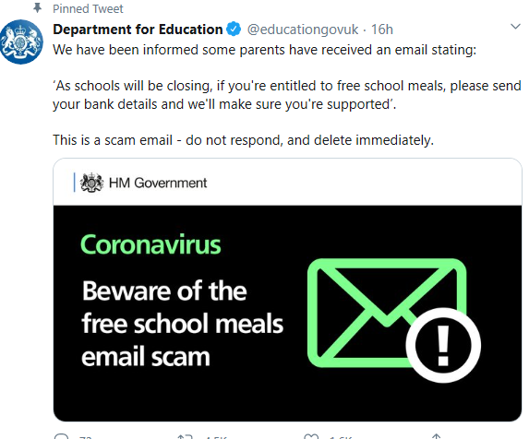
The DfE have tweeted about scam emails being sent out. Please be aware of this and do not provide your bank details if you receive an email about free school meals.

